

《高级语言程序设计》
课程报告

姓名： 张梦南

班级： 自动化221

学号： 1220310013

自动化与电气工程学院

2023-12
课程设计一：
一、设计要求：
输入一段文本，要求对其中的每个单词进行反序，并按照反序后的单词的首字母排序输出这段文本（首字母相同，按照第二个字母排序，依此类推）。
输出格式与输入格式相同。
二、设计分析：
利用课本第五章（使用顺序容器和分析字符串）中所split函数，实现将字符串拆分为单词。参考第六章（使用库算法）中的回文程序，实现对单词进行反转。最后按照反转后单词的首字母对单词进行排序。
三、主要代码分析：
- string reverseString(const string& s) {
- return string(s.rbegin(), s.rend());
- }
借助STL库实现。s.rbegin()是反向迭代器，指向容器的最后一个元素。s.rend()也是反向迭代器，指向第一个元素前面的位置。用了string的其中一种构造函数：string(Iter begin, Iter end)。

- std::sort(words.begin(), words.end());
利用sort函数来实现根据首字母对单词排序。
四、程序运行示例：
课程设计一程序运行示例如图1.1所示。
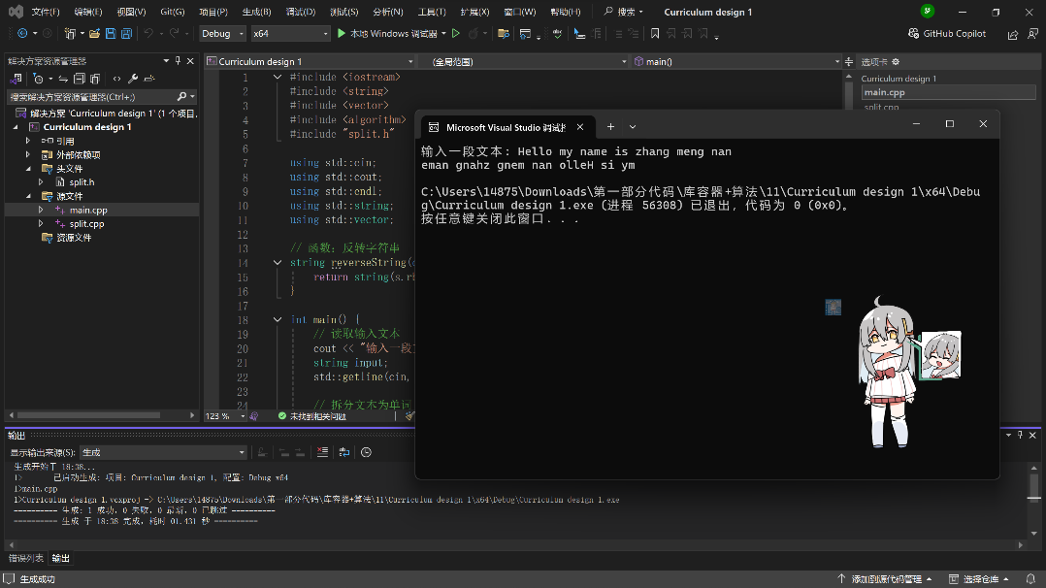
图1.1 课程设计一程序运行示例
五、附完整代码：
main.cpp:
- #include <iostream>
- #include <string>
- #include <vector>
- #include <algorithm>
- #include "split.h"

- using std::cin;
- using std::cout;
- using std::endl;
- using std::string;
- using std::vector;

- // 函数：反转字符串
- string reverseString(const string& s) {
- return string(s.rbegin(), s.rend());
- }

- int main() {
- // 读取输入文本
- cout << "输入一段文本: ";
- string input;
- std::getline(cin, input);

- // 拆分文本为单词
- vector<string> words = split(input);

- // 对每个单词进行反转
- for (auto& word : words) {
- word = reverseString(word);
- }

- // 按照反转后的单词排序
- std::sort(words.begin(), words.end());

- // 输出排序后的单词，保持与原输入格式一致
- for (size_t i = 0; i < words.size(); ++i) {
- if (i > 0) {
- cout << " "; // 单词间加空格
- }
- cout << words[i];
- }
- cout << endl;

- return 0;
- }

split.h:
- #ifndef GUARD_split_h
- #define GUARD_split_h

- #include <vector>
- #include <string>
- std::vector<std::string> split(const std::string&);

- #endif

split.cpp:
- #include <cctype>
- #include <string>
- #include <vector>

- #include "split.h"

- using std::vector;
- using std::string;

- #ifndef _MSC_VER
- using std::isspace;
- #endif

- vector<string> split(const string& s)
- {
- vector<string> ret;
- typedef string::size_type string_size;
- string_size i = 0;

- // invariant: we have processed characters `['original value of `i', `i)'
- while (i != s.size()) {
- // ignore leading blanks
- // invariant: characters in range `['original `i', current `i)' are all spaces
- while (i != s.size() && isspace(s[i]))
- ++i;

- // find end of next word
- string_size j = i;
- // invariant: none of the characters in range `['original `j', current `j)' is a space
- while (j != s.size() && !isspace(s[j]))
- ++j;

- // if we found some nonwhitespace characters
- if (i != j) {
- // copy from `s' starting at `i' and taking `j' `\-' `i' chars
- ret.push_back(s.substr(i, j - i));
- i = j;
- }

- }
- return ret;
- }

课程设计二：
一、设计要求：
输入一段文本，将其中的http协议的url输出，按照其单词首字母次序输出（首字母相同，按照第二个字母排序，依此类推）。
二、设计分析：
利用第六章（使用库算法）中的查找URL程序所使用的urls函数，来实现从文本中提取出所有有效的 URL。按照URL的单词首字母次序进行排序。
三、主要代码分析：
- vector<string> urls = find_urls(input);
利用urls函数从输入文本中提取出URL链接。

- vector<string> http_urls;
- for (const string& url : urls) {
- if (url.find("http://") == 0 || url.find("https://") == 0) {
- http_urls.push_back(url);
- }
- }
将提取出来的URL以http或https分成两类（结果优先打印输出http）

- sort(http_urls.begin(), http_urls.end());
利用sort函数来实现根据首字母对单词排序。（与课程设计一中的排序实现方式相同）
四、程序运行示例：
课程设计二程序运行示例如图2.1所示。
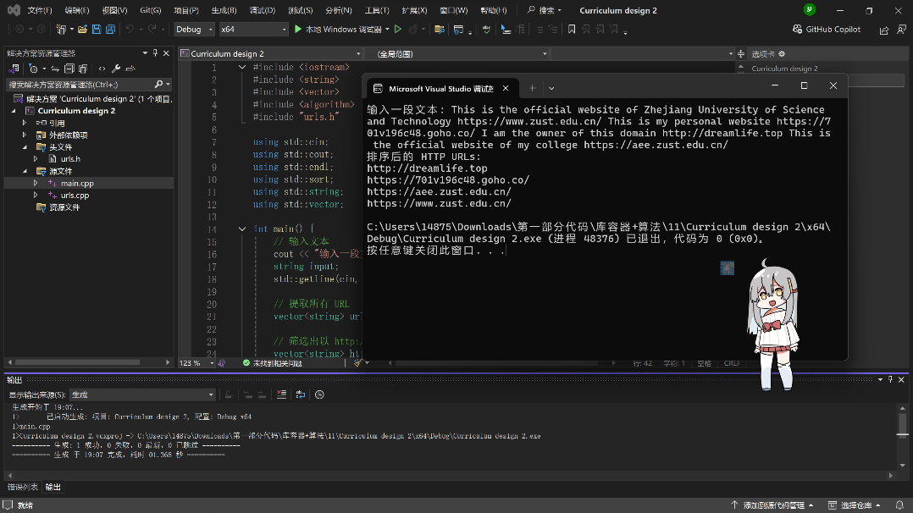
图2.1 课程设计二程序运行示例
五、附完整代码：
main.cpp:
- #include <iostream>
- #include <string>
- #include <vector>
- #include <algorithm>
- #include "urls.h"

- using std::cin;
- using std::cout;
- using std::endl;
- using std::sort;
- using std::string;
- using std::vector;

- int main() {
- // 输入文本
- cout << "输入一段文本: ";
- string input;
- std::getline(cin, input);

- // 提取所有 URL
- vector<string> urls = find_urls(input);

- // 筛选出以 http:// 或 https:// 开头的 URL
- vector<string> http_urls;
- for (const string& url : urls) {
- if (url.find("http://") == 0 || url.find("https://") == 0) {
- http_urls.push_back(url);
- }
- }

- // 按字母顺序排序
- sort(http_urls.begin(), http_urls.end());

- // 输出结果
- cout << "排序后的 HTTP URLs:" << endl;
- for (const string& url : http_urls) {
- cout << url << endl;
- }

- return 0;
- }

urls.h:
- #ifndef GUARD_urls_h
- #define GUARD_urls_h

- #include <vector>
- #include <string>

- std::vector<std::string> find_urls(const std::string& s);

- #endif

urls.cpp:
- #include <algorithm>
- #include <cctype>
- #include <string>
- #include <vector>

- #include "urls.h"

- using std::find;
- using std::find_if;

- #ifndef _MSC_VER
- using std::isalnum;
- using std::isalpha;
- using std::isdigit;
- #endif

- using std::search;
- using std::string;
- using std::vector;

- bool not_url_char(char);

- string::const_iterator
- url_end(string::const_iterator, string::const_iterator);

- string::const_iterator
- url_beg(string::const_iterator, string::const_iterator);
- vector<string> find_urls(const string& s)
- {
- vector<string> ret;
- typedef string::const_iterator iter;
- iter b = s.begin(), e = s.end();

- // look through the entire input
- while (b != e) {

- // look for one or more letters followed by `://'
- b = url_beg(b, e);

- // if we found it
- if (b != e) {
- // get the rest of the \s-1URL\s0
- iter after = url_end(b, e);

- // remember the \s-1URL\s0
- ret.push_back(string(b, after));

- // advance `b' and check for more \s-1URL\s0s on this line
- b = after;
- }
- }
- return ret;
- }

- string::const_iterator
- url_end(string::const_iterator b, string::const_iterator e)
- {
- return find_if(b, e, not_url_char);
- }

- bool not_url_char(char c)
- {
- // characters, in addition to alphanumerics, that can appear in a \s-1URL\s0
- static const string url_ch = "~;/?:@=&$-_.+!*'(),";

- // see whether `c' can appear in a \s-1URL\s0 and return the negative
- return !(isalnum(c) ||
- find(url_ch.begin(), url_ch.end(), c) != url_ch.end());
- }

- string::const_iterator
- url_beg(string::const_iterator b, string::const_iterator e)
- {
- static const string sep = "://";

- typedef string::const_iterator iter;

- // `i' marks where the separator was found
- iter i = b;

- while ((i = search(i, e, sep.begin(), sep.end())) != e) {

- // make sure the separator isn't at the beginning or end of the line
- if (i != b && i + sep.size() != e) {

- // `beg' marks the beginning of the protocol-name
- iter beg = i;
- while (beg != b && isalpha(beg[-1]))
- --beg;

- // is there at least one appropriate character before and after the separator?
- if (beg != i && !not_url_char(i[sep.size()]))
- return beg;
- }

- // the separator we found wasn't part of a \s-1URL\s0; advance `i' past this separator
- i += sep.size();
- }
- return e;
- }

课程设计三：
一、设计要求：
输入学生姓名、期中成绩、期末成绩和平时成绩，计算他的总评成绩。将不及格学生信息和及格学生信息分开输出，并按照姓名首字母排序。
二、设计分析：
利用第四章（组织程序和数据）中所使用的student_info函数和median函数来储存所输入的学生数据，利用grade函数来计算学生的总评成绩。最后按学生姓名字母顺序分别输出及格和不及格学生的信息。
总评成绩 = 20%*期中成绩 + 40%*期末成绩 + 40%*作业成绩
三、主要代码分析：
- const double PASS_GRADE = 60.0;
设置总评及格成绩为60分。

- vector<Student_info> pass, fail;
- for (const auto& student : students) {
- if (grade(student) >= PASS_GRADE) {
- pass.push_back(student);
- }
- else {
- fail.push_back(student);
- }
- }
利用循环（for）加判断（if&else）将学生根据总评成绩分为及格和不及格。

- std::sort(pass.begin(), pass.end(), compare);
- std::sort(fail.begin(), fail.end(), compare);
利用sort函数来实现根据学生名字首字母来排序。（与课程设计一和二中的排序实现方式相同）
四、程序运行示例：
课程设计二程序运行示例如图3.1所示。
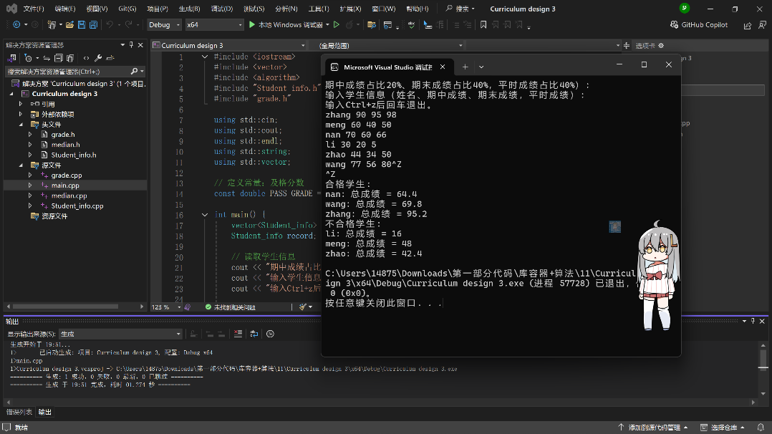
图3.1 课程设计三程序运行示例
五、附完整代码：
main.cpp:
- #include <iostream>
- #include <vector>
- #include <algorithm>
- #include "Student_info.h"
- #include "grade.h"

- using std::cin;
- using std::cout;
- using std::endl;
- using std::string;
- using std::vector;

- // 定义常量：及格分数
- const double PASS_GRADE = 60.0;

- int main() {
- vector<Student_info> students;
- Student_info record;

- // 读取学生信息
- cout << "期中成绩占比20%、期末成绩占比40%，平时成绩占比40%）:" << endl;
- cout << "输入学生信息（姓名、期中成绩、期末成绩，平时成绩）:" << endl;
- cout << "输入Ctrl+z后回车退出。" << endl;

- while (read(cin, record)) {
- students.push_back(record);
- }

- // 将学生分为及格和不及格两组
- vector<Student_info> pass, fail;
- for (const auto& student : students) {
- if (grade(student) >= PASS_GRADE) {
- pass.push_back(student);
- }
- else {
- fail.push_back(student);
- }
- }

- // 按名字排序
- std::sort(pass.begin(), pass.end(), compare);
- std::sort(fail.begin(), fail.end(), compare);

- // 输出及格学生信息
- cout << "合格学生:" << endl;
- for (const auto& student : pass) {
- cout << student.name << ": 总成绩 = " << grade(student) << endl;
- }

- // 输出不及格学生信息
- cout << "不合格学生:" << endl;
- for (const auto& student : fail) {
- cout << student.name << ": 总成绩 = " << grade(student) << endl;
- }

- return 0;
- }

student_info.h:
- #ifndef GUARD_Student_info
- #define GUARD_Student_info

- // `Student_info.h' header file
- #include <iostream>
- #include <string>
- #include <vector>

- struct Student_info {
- std::string name;
- double midterm, final;
- std::vector<double> homework;
- };

- bool compare(const Student_info&, const Student_info&);
- std::istream& read(std::istream&, Student_info&);
- std::istream& read_hw(std::istream&, std::vector<double>&);
- #endif

student_info.cpp:
- // source file for `Student_info'-related functions
- #include "Student_info.h"

- using std::istream; using std::vector;

- bool compare(const Student_info& x, const Student_info& y)
- {
- return x.name < y.name;
- }

- istream& read(istream& is, Student_info& s)
- {
- // read and store the student's name and midterm and final exam grades
- is >> s.name >> s.midterm >> s.final;

- read_hw(is, s.homework); // read and store all the student's homework grades
- return is;
- }

- // read homework grades from an input stream into a `vector<double>'
- istream& read_hw(istream& in, vector<double>& hw)
- {
- if (in) {
- // get rid of previous contents
- hw.clear();

- // read homework grades
- double x;
- while (in >> x)
- hw.push_back(x);

- // clear the stream so that input will work for the next student
- in.clear();
- }
- return in;
- }

median.h:
- #ifndef GUARD_median_h
- #define GUARD_median_h

- // `median.h'--final version
- #include <vector>
- double median(std::vector<double>);

- #endif

median.cpp:
- // source file for the `median' function
- #include <algorithm> // to get the declaration of `sort'
- #include <stdexcept> // to get the declaration of `domain_error'
- #include <vector> // to get the declaration of `vector'

- using std::domain_error; using std::sort; using std::vector;

- #include "median.h"

- // compute the median of a `vector<double>'
- // note that calling this function copies the entire argument `vector'
- double median(vector<double> vec)
- {
- #ifdef _MSC_VER
- typedef std::vector<double>::size_type vec_sz;
- #else
- typedef vector<double>::size_type vec_sz;
- #endif

- vec_sz size = vec.size();
- if (size == 0)
- throw domain_error("median of an empty vector");

- sort(vec.begin(), vec.end());

- vec_sz mid = size/2;

- return size % 2 == 0 ? (vec[mid] + vec[mid-1]) / 2 : vec[mid];
- }

grade.h:
- #ifndef GUARD_grade_h
- #define GUARD_grade_h

- #include <vector>
- #include "Student_info.h"

- double grade(double, double, double);
- double grade(double, double, const std::vector<double>&);
- double grade(const Student_info&);

- bool pgrade(const Student_info&);
- bool fgrade(const Student_info&);

- #endif

grade.cpp:
- #include <stdexcept>
- #include <vector>
- #include "grade.h"
- #include "median.h"
- #include "Student_info.h"

- using std::domain_error; using std::vector;

- // compute a student's overall grade from midterm and final exam grades and homework grade
- double grade(double midterm, double final, double homework)
- {
- return 0.2 * midterm + 0.4 * final + 0.4 * homework;
- }

- // compute a student's overall grade from midterm and final exam grades
- // and vector of homework grades.
- // this function does not copy its argument, because `median' does so for us.
- double grade(double midterm, double final, const vector<double>& hw)
- {
- if (hw.size() == 0)
- throw domain_error("student has done no homework");
- return grade(midterm, final, median(hw));
- }

- double grade(const Student_info& s)
- {
- return grade(s.midterm, s.final, s.homework);
- }

- // predicate to determine whether a student failed
- bool fgrade(const Student_info& s)
- {
- return grade(s) < 60;
- }

- bool pgrade(const Student_info& s)
- {
- return !fgrade(s);
- }

评分表

序号 | 内容 | 得分
1 | 能利用标准库进行编程，库函数使用正确。（0.5）
2 | 软件架构合理，功能模块划分清晰，代码编写规范，结果正确。（0.5）
 | 总计

评分人：

日期：

